Applying spatial statistics to spatio-temporal big data in order to identifying statistically significant spatial hot spots
using Apache Spark (Change Heading)
Arizona State University
Namrata Nayak (1212408767), Nimshi Venkat (1209396432), Shrinivas Bhat (1212415813), Varun Chandra Jammula (1207940275)

ABSTRACT
Need to write

INTRODUCTION
We have implemented GeoSpark, a framework used for processing large-scale spatial data. We have implemented it on a Hadoop cluster with Apache Spark.
This paper contains the analysis of tasks that we performed on the spark cluster using geospark API. The following tasks are included in this report.
(check formatting here and bullets)

- Create GeoSpark SpatialRDD (Point RDD).
- Spatial Range Query:
- Query the PointRDD
- Build R-Tree index on PointRDD then query this PointRDD
- Spatial KNN Query:
- Query the PointRDD and find 5 nearest neighbors
- Build R-Tree index on PointRDD then query this PointRDD again
- Spatial Join Query:
- Join the PointRDD using Equal grid without R-Tree index
- Join the PointRDD using Equal grid with R-Tree index
- Join the PointRDD using R-Tree grid without R-Tree index
- Spatial Join Query using simple Cartesian Product algorithm
- Apply spatial statistics to spatio-temporal big data in order to identify statistically significant spatial hot spots using Apache Spark (Data used and applied as per ACM SIGSPATIAL GISCUP-2016)

ARCHITECTURE

Add explaination

Overall Architecture:
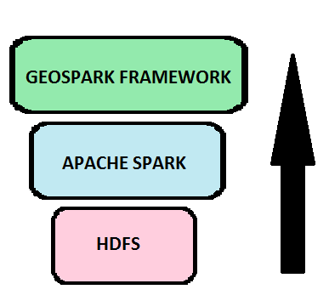

HDFS Architecture:
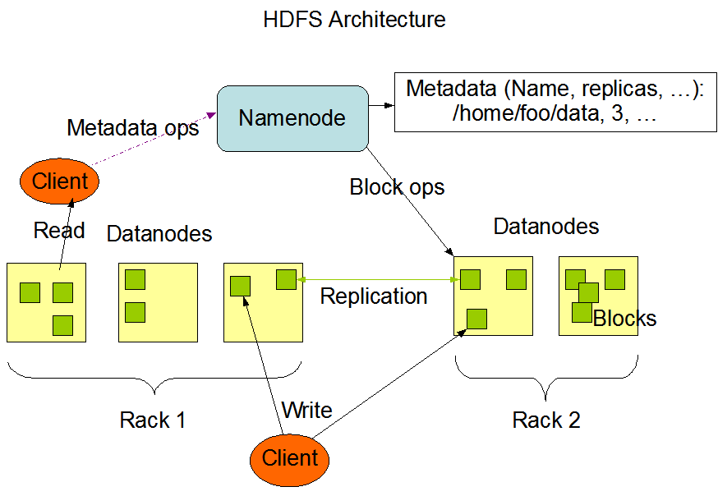

Apache Spark Architecture:
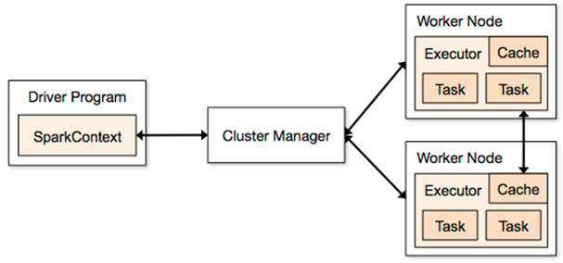
Geo Spark Architecture:
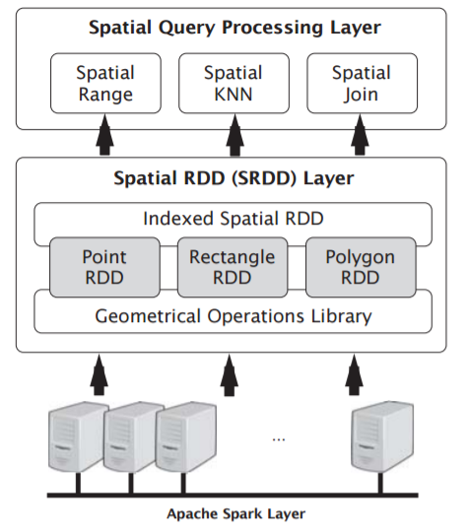

IMPLEMENTATION
The project implements distributed dataset operation using Apache Spark and GeoSpark. Project is divided into 3 phases. In each phase efficiency of different API’s of GeoSpark and Apache Spark is measured. Distributed execution of queries on different GeoSprak specific RDD’s such as SpatialRDD, PointRDD etc with either indexing or without indexing is performed in phase 1.
Phase 2 will introduce a tool called Ganglia which is used to measure performance of the each cluster in the distributed system. A fair comparison between each task of the phase 1 is done using performance recorded by Ganglia. Also a spatial join query is performed using Cartesian product algorithm, which is used to compare the efficiency of joining PointRDD using Equal grid and R-tree grid with or without R-tree indexing.

Phase 1: GeoSpark Queries
In this phase distributed execution of the GeoSpark queries is done using setup mentioned in section 4. The steps and the pseudocode of the queries we executed are as below:

Create GeoSpark SpatialRDD:
SpatialRDD is an extension of Apache spark RDD in a spatial dataset. Spark shell is used to load the GeoSpark jar and run the code.

Spatial Range Query:
Range query on the spatial data returns whether a given point is in the window created by a pair of points.
Pseudo Code:
- Given a pair of points of the window, create a Envelope.
- A PointRDD is created with the list of points that has to be range sorted.
- Perform RangeQuery using the Envelope and PointRDD object.
- Collect & aggregate the result in collection as a list of points.
- We make same query with R-tree indexing - load the PointRDD.

Spatial KNN query:
For every PointRDD object we try to find nearest ‘n’ neighbors to the query point. The pseudocode is as following.
- Create a point for which KNN has to computed.
- Load PointRDD from the csv file.
- Run Spatial KNN query to find ‘n’ nearest neighbors
- Aggregate the final result.
- We make same query, with R-tree indexing load the PointRDD.

Spatial Join Query:
RectangleRDD is a set of envelope and PointRDD, on which we perform a spatial join query. This would give a list of points that are present in the envelope.
- Load PointRDD and RectangleRDD from the csv values.
- Perform join operation on these two RDD’s and aggregate the result.
- Try doing the operation with and without R-tree indexing, on a Equal grid or R-tree grid object.

Phase 2: Performance measurement of different queries
The phase is about writing an algorithm to compute spatial join query using Cartesian product algorithm. And comparing the performances of each query of Phase 1 and Phase 2, using a tool called Ganglia.

Spatial join query using Cartesian product Algorithm:
We implement a spatial join query using a simple Cartesian product Algorithm with the following algorithm.
- Load the PointRDD and RectangleRDD from their respective datasets.
- Collect all the envelopes from the RectangleRDD using rawSpatialRDD.
- For every envelope in the list, do:
  - SpatialRangeQuery on the PointRDD and the envelope.
  - Collect all the points as tuple.
- Parallelize the collected data into JavaPairRDD and return it.

Performance analysis:
For every task in Phase 1 and task 1 of Phase 2, compare the execution time, average memory, average CPU utilization of the overall cluster using performance tool such as Ganglia. Setup for Ganglia is mentioned in section 4 and result of each of such comparison is mentioned in section 5.

Phase 3:

Add content from google doc

EXPERIMENTAL SETUP
The system configuration that we had to setup for this project is mentioned below: (Please recheck these configurations)
a. Open JDK 1.7.0
b. Hadoop 2.7.3
c. Spark 2.1.0
d. SSH
e. Maven 3
f. Eclipse Neon IDE

(Include master system configs like core etc and workers config)

RESULTS
Throughout the project we conducted experiments that were either finding some output or analyzing the performance. For each of the phases implemented as mentioned in section 3, we produce the output or we draw a conclusion.

Phase 1:
The phase 1 is all about setting up the Hadoop and Spark environment and performing some query operation using GeoSpark framework.

Phase 2:
Ganglia – a tool that analyses performance of each cluster. We have performed different tasks on phase 1 and 2. The result and analysis are as follows.

Difference between Spatial Range Queries a) querying PointRDD b)Build R-tree index on PointRDD and then query the PointRDD

Iteration:150 | Execution Time | Average Memory | CPU Utilization (%)
2a | 92ms | 13.8 G | 71.9
2b | 81ms | 13.9 G | 68.8
Tab 5.1 Performance metrics for query 2a, 2b

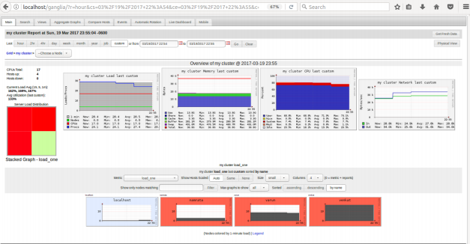
Fig 5.1 Cluster report of query 2a of Phase 1
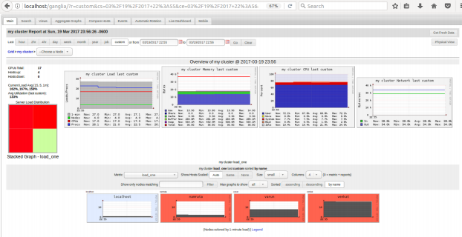
Fig 5.2 Cluster report of query 2b of Phase 1

Conclusion:
Execution time and CPU utilization were better with R-tree indexing while building PointRDD. And memory utilization were the almost same. Thus we can conclude that R-tree indexing runs faster because it uses R-tree data structure which is ideal for spatial access methods. R-tree data structure groups nearby objects bound by minimum rectangle.

Difference between Spatial KNN Queries a) querying PointRDD and finding 5 nearest neighbors b)Build R-tree index on PointRDD and then query the PointRDD again

Iteration:150 | Execution Time | Average Memory | CPU Utilization (%)
3a | 94ms | 13.8 G | 71.6
3b | 143ms | 14.2 G | 72.9
Tab 5.2 Performance metrics for query 3a, 3b

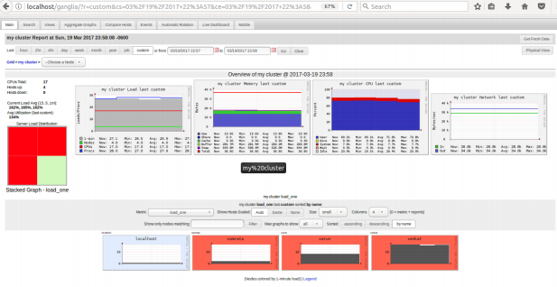
Fig 5.3 Cluster report of query 3a of Phase 1
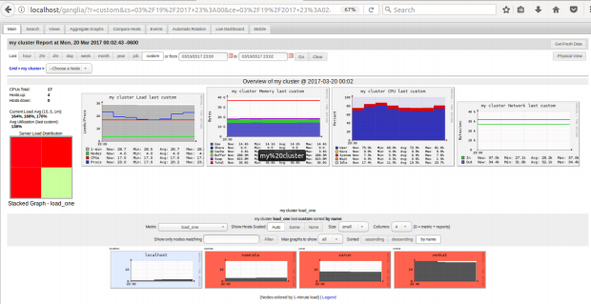
Fig 5.4 Cluster report for query 3b of Phase 1

Conclusion:
Execution time and CPU utilization were better without R-tree indexing while building PointRDD. Since finding nearing 5 neighbors becomes burden with indexing hence performance was little poor.

Difference between Spatial Join Queries: Create a RectangleRDD and join it with PointRDD a) join PointRDD using Equal grid without R-tree index b) join PointRDD using Equal grid with R-tree index c) join PointRDD using R-tree grid without R-tree index and Task 1 of phase 2 i.e Spatial Join Query using simple Cartesian product algorithm

Iteration:10 | Execution Time | Average Memory | CPU Utilization (%)
4a | 159163ms | 13.6 G | 74.5
4b | 45385ms | 13.9 G | 73.8
4c | 56589ms | 14.0 G | 76.2
Phase 2 - T1 | 915393ms | 14.1 G | 83.0
Tab 5.3 Performance metrics for query 4a, 4b, 4c and Phase 2 Task 1
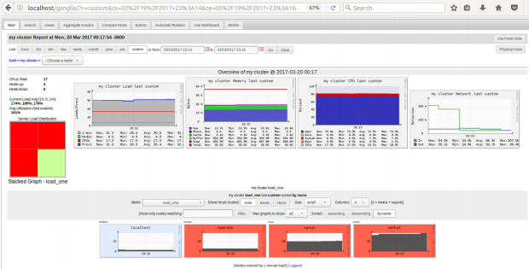
Fig 5.5 Cluster report of query 4a of Phase 1
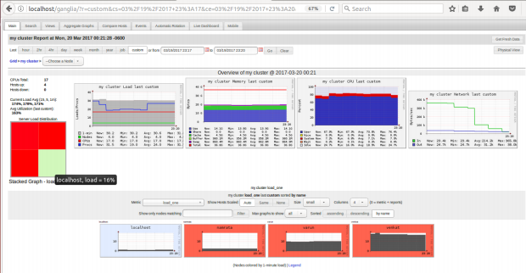
Fig 5.6 Cluster report of query 4b of Phase 1
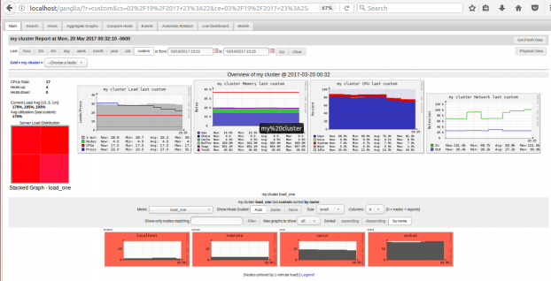
Fig 5.7 Cluster report of query 4c of Phase 1
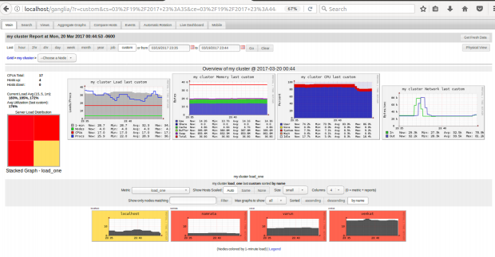
Fig 5.8 Cluster report of task 1 of Phase 2

Conclusion:
Execution time and CPU utilization in case of Equal Grid with R-tree indexing was better compared to without indexing. And R-tree grid without indexing was also had better Execution time and CPU utilization when compared to Equal grid without indexing. However it Equal grid with indexing was much better.
Task 1 of phase 2 was to do the spatial join with simple Cartesian product algorithm which was worst performing among all of them.
(Add Phase 3 result/output and screenshots)

ACKNOLEDGEMENT
Need to write

REFERENCES
Need to write

